**Aim:**

To design and implement a cloud-based Payroll Processing System using Zoho Creator, where employee salary details are entered through a form, Gross Pay is calculated automatically using formula fields, and the application is deployed as a SaaS (Software-as-a-Service) with public access.

**Procedure:**

1. Create Application

* Open Zoho Creator and create a new application named *Payroll Processing System*.

2. Design Form

* Add fields: Employee Name, Experience in Present, Overall Experience, Basic Pay, HRA, DA, and Deductions.
* Add Formula Fields:
  + Gross Pay = Basic Pay + HRA + DA

3. Generate Report

* Create a report (*All Employee Payrolls*) to display entered employee details along with calculated Gross Pay and Net Pay.

4. Publish Application

* Go to Settings → User Permissions → Make Public.
* Generate the public URL and test in an incognito browser.

5. Verify Output

* Enter sample employee records.
* Check that Gross Pay and Net Pay are automatically calculated and visible in the report.

**Payroll Form (Public URL):**

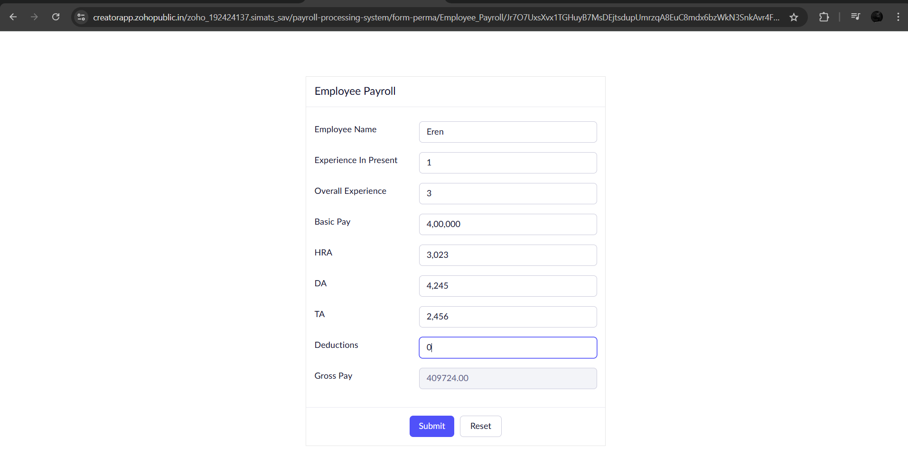

**All Employee Payrolls Report:**

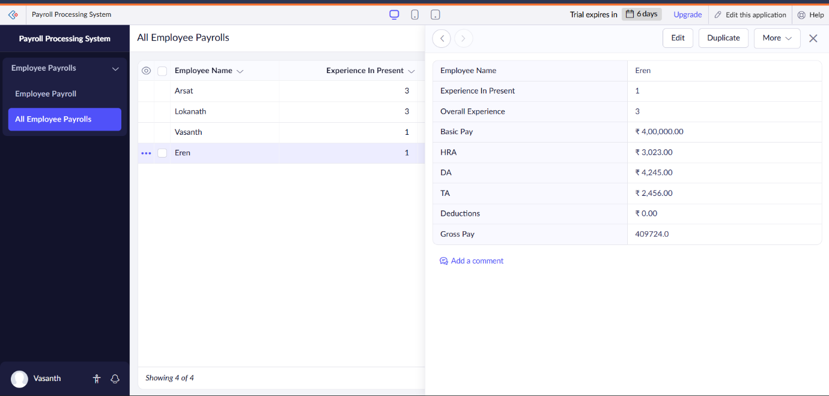

**Result:**

The Payroll Processing System was successfully created and deployed on Zoho Creator. Employee details were entered through a cloud-based form, Gross Pay was auto-calculated using formula fields, and the application was made publicly accessible via a SaaS model.